How To Use Python On A Web Page With Jinja2
Q. I am learning flask, can you tell me what is the main purpose/use of Jinja2?
Ans. Absolutely! Jinja2 is a powerful templating engine that Flask uses to dynamically generate HTML content. Its main purpose is to allow you to embed Python-like expressions directly into your HTML files, making web pages more interactive and maintainable.
Here's why Jinja2 is essential:
- Dynamic Content Rendering: You can pass data from Flask routes to templates and render it dynamically (e.g., user profiles, search results).
- Template Inheritance: It enables reusable templates, reducing redundancy in HTML code by allowing child templates to extend base templates.
- Control Flow & Logic: You can use loops ({% for %}) and conditionals ({% if %}) inside HTML to control how elements are displayed.
- Filters & Macros: Built-in filters help format data (like converting text to uppercase), while macros allow reusable template functions.
For instance, instead of writing static HTML, you could do something like this:
{% for user in users %}
<p>{{ user.name }} - {{ user.email }}</p>
{% endfor %}
And Flask would populate the page with a list of users passed from the backend. Jinja2 makes building Flask applications much more flexible!
Since you're diving into Flask, do you need help setting up your templates, or troubleshooting any Jinja2 errors?
Q. When you say, "- Filters & Macros: Built-in filters help format data (like converting text to uppercase), while macros allow reusable template functions. " does format() function used in return "<H1>Hello {}!!!</H1>".format(name), come under filters or macros? Also, give examples of filters and macros used in flask!
A. Great question! The format() function in Python is not a Jinja2 filter or macro. Instead, it is a standard Python string method used to insert values into a string.
Filters vs. Macros in Jinja2
- Filters modify data before rendering it in a template. Think of them like post-processing tools—they take an input and transform it.
- Macros are reusable template functions that allow you to define blocks of code that can be called multiple times, similar to functions in Python.
Examples of Filters
Jinja2 provides several built-in filters to manipulate data in Flask templates. Here are some commonly used ones:
- uppercase: Converts text to uppercase
- {{ "hello world" | upper }} <!-- Output: HELLO WORLD -->
- lower: Converts text to lowercase
- {{ "HELLO" | lower }} <!-- Output: hello -->
- default: Provides a fallback value if the variable is None
- {{ user.name | default("Guest") }}
- length: Returns the length of a list or string
- {{ users | length }} <!-- Output: Number of users -->
Examples of Macros
Macros let you define reusable HTML components inside Jinja2 templates.
{% macro greeting(name) %}
<h1>Hello, {{ name }}!</h1>
{% endmacro %}

<!-- Calling the macro -->
{{ greeting("Shamsunder") }}
Output:
<h1>Hello, Shamsunder!</h1>
Macros are particularly useful when creating repetitive UI elements, like custom buttons or form fields.
- Just like Flask’s Jinja2, even Django has a templating language known as “Django Template Language(DTL)”. Jinja2 is more powerful than DTL, Jinja2 is more powerful, offers more control and is flexible.
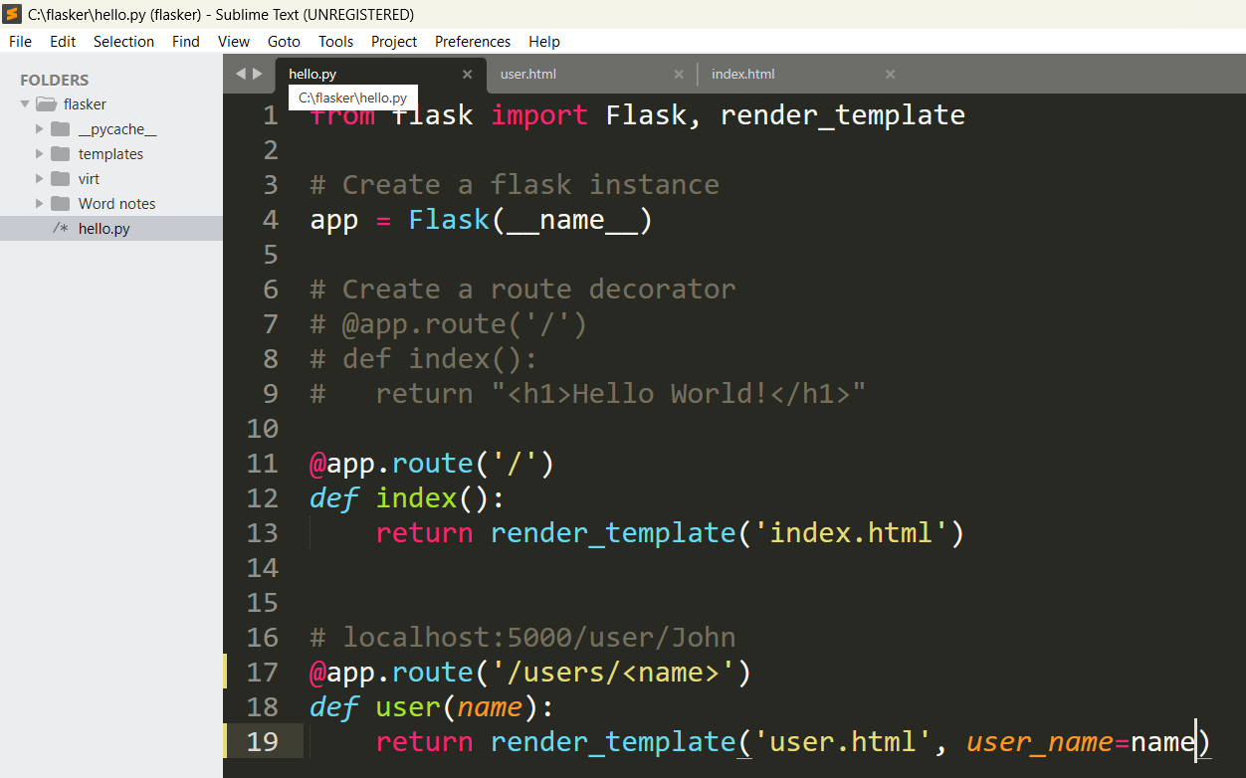

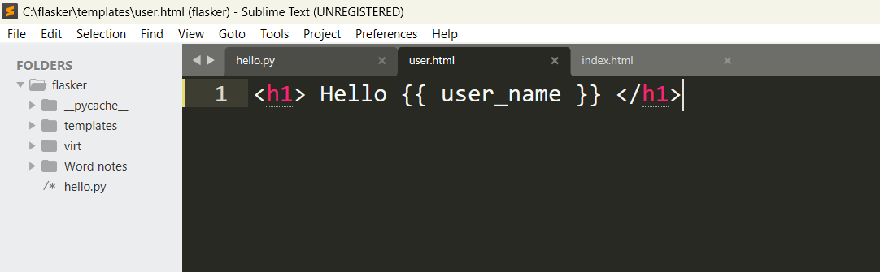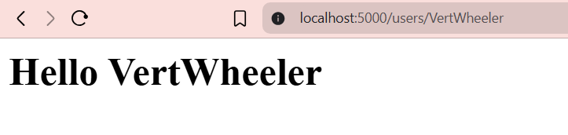

2nd Program discussed:
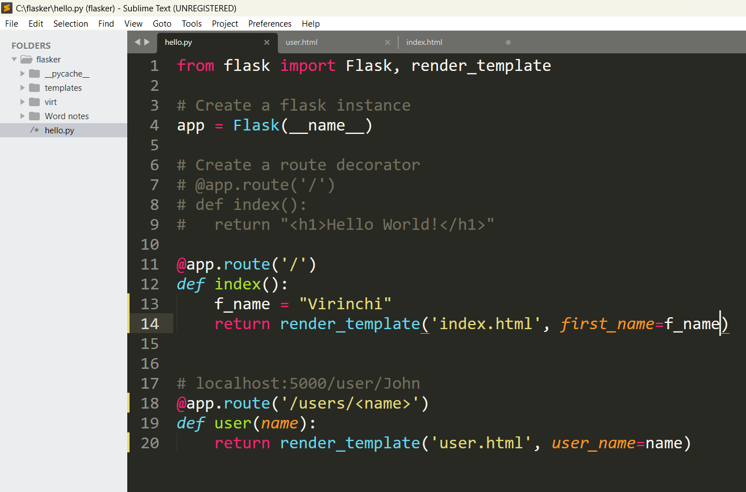
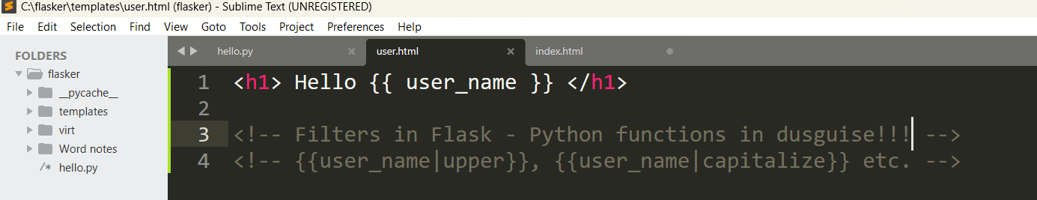

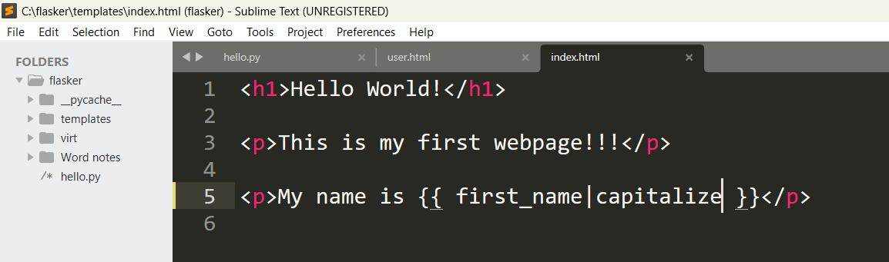

Output:
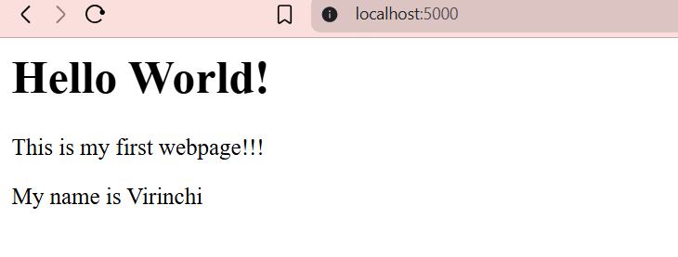

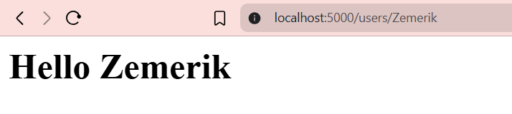

13-05-25

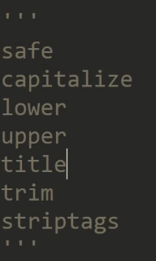

- The above things in the pic are called as called as filters. Filters help in formatting data (like converting text to uppercase).
- Let’s see filter’s effect in 3 diff. cases:
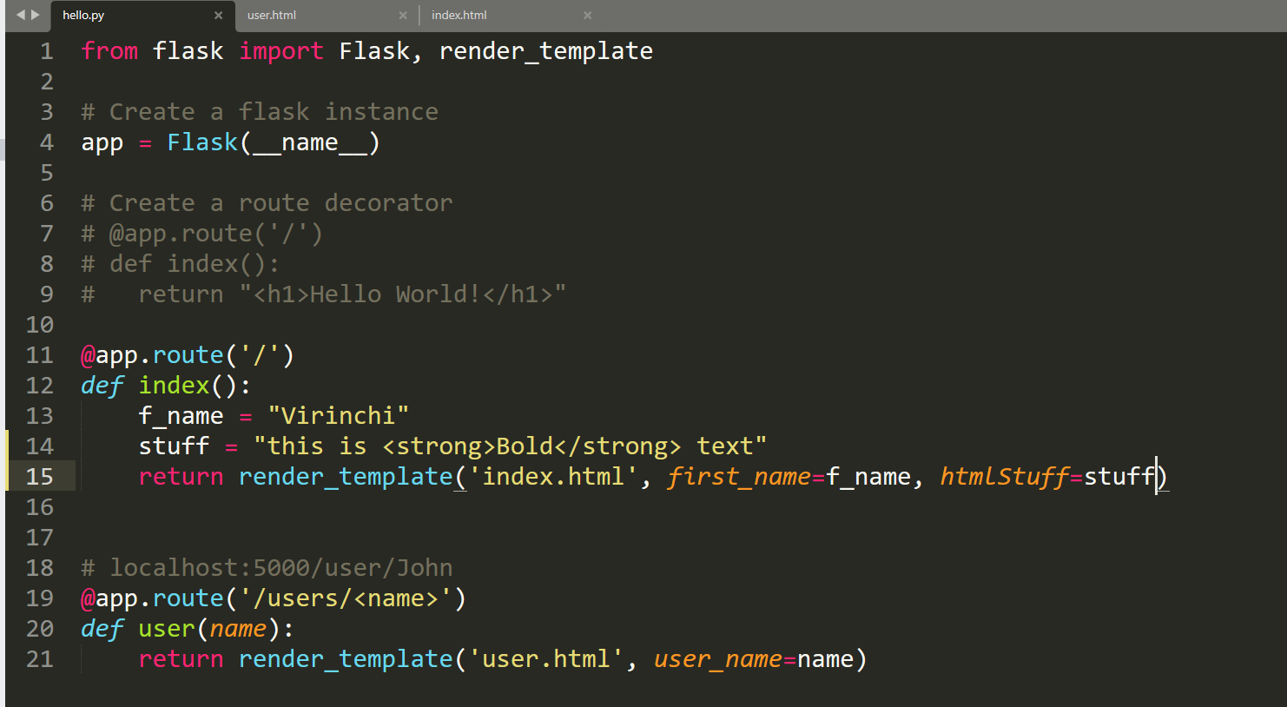

a) 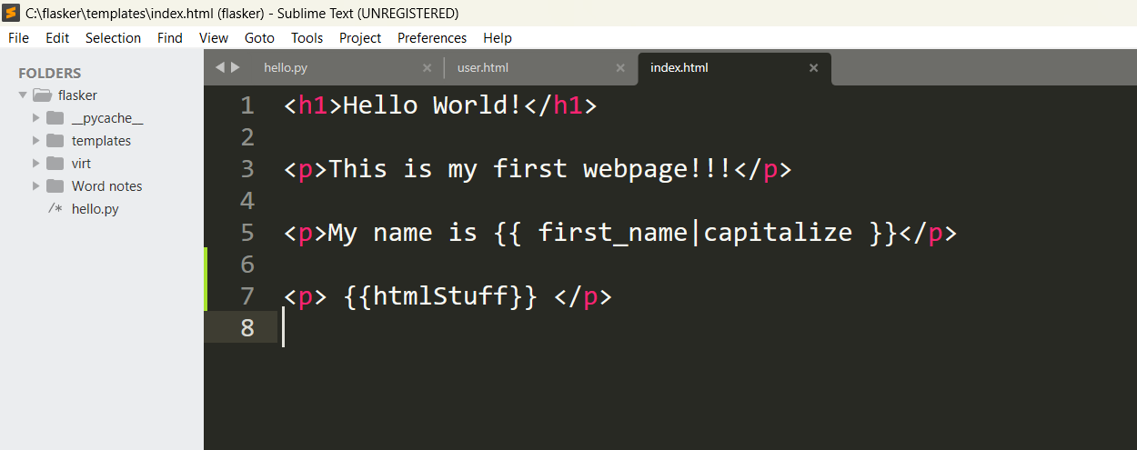

o/p: 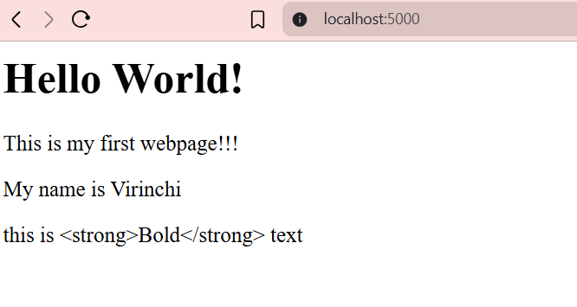
b)
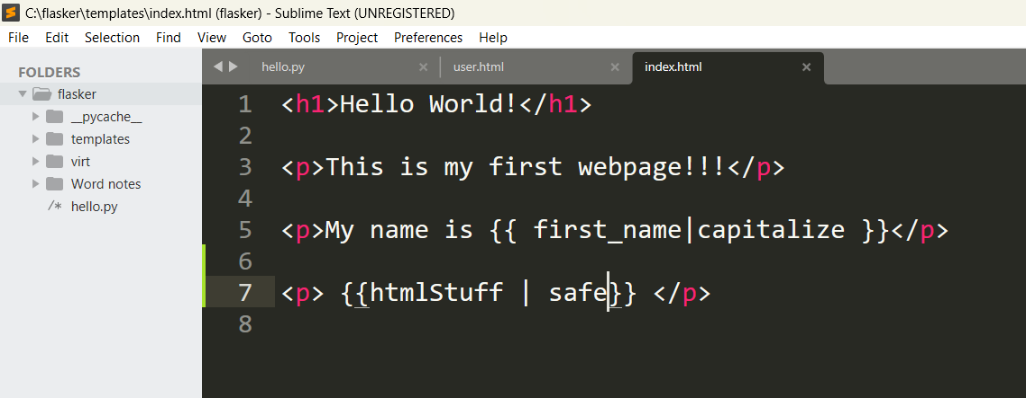

o/p:
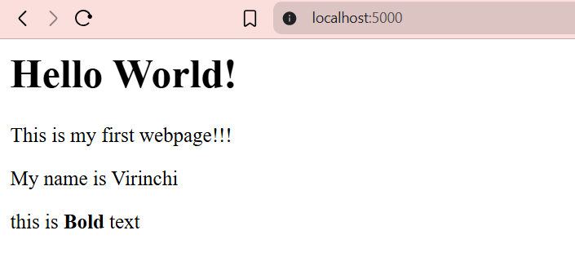

c)
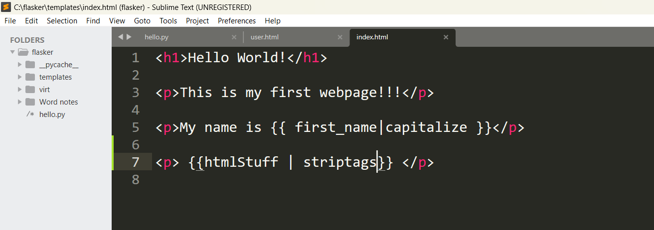

o/p:
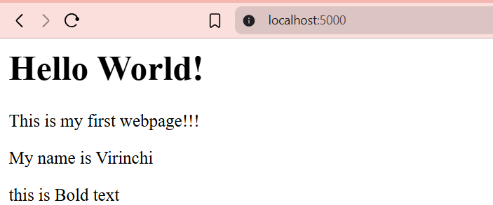

- 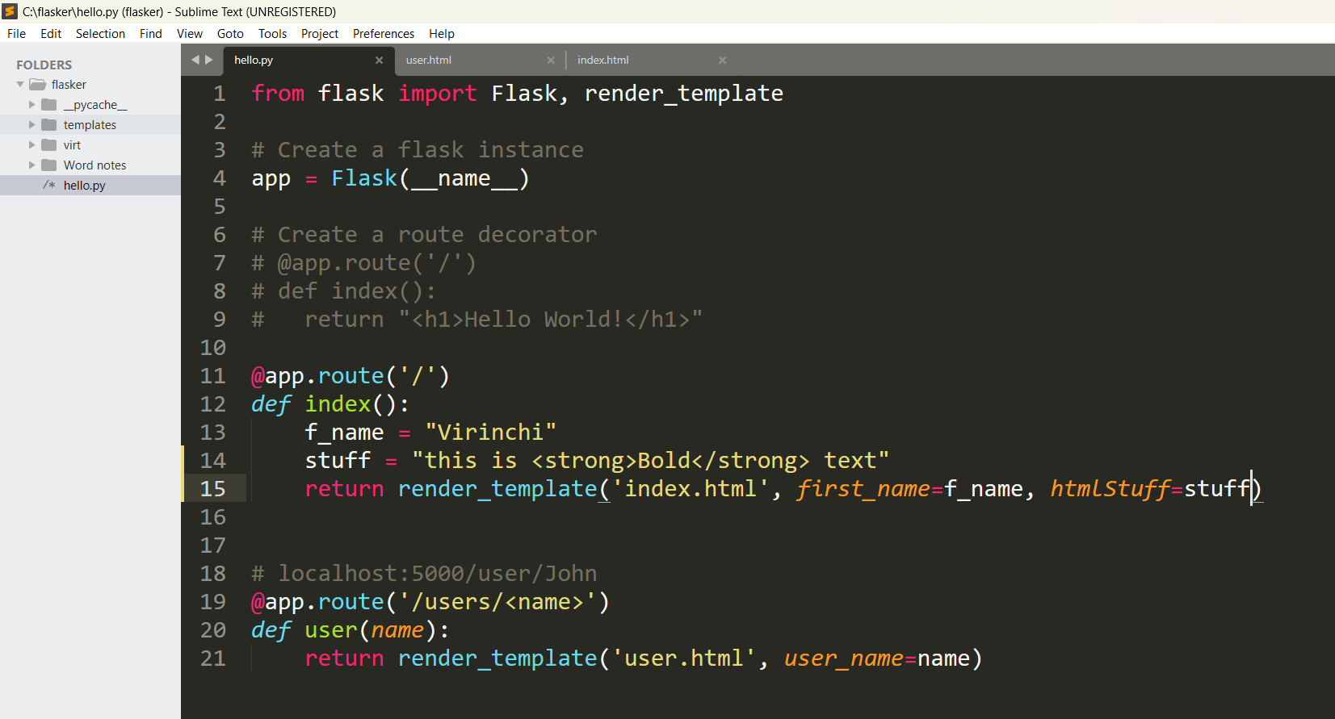
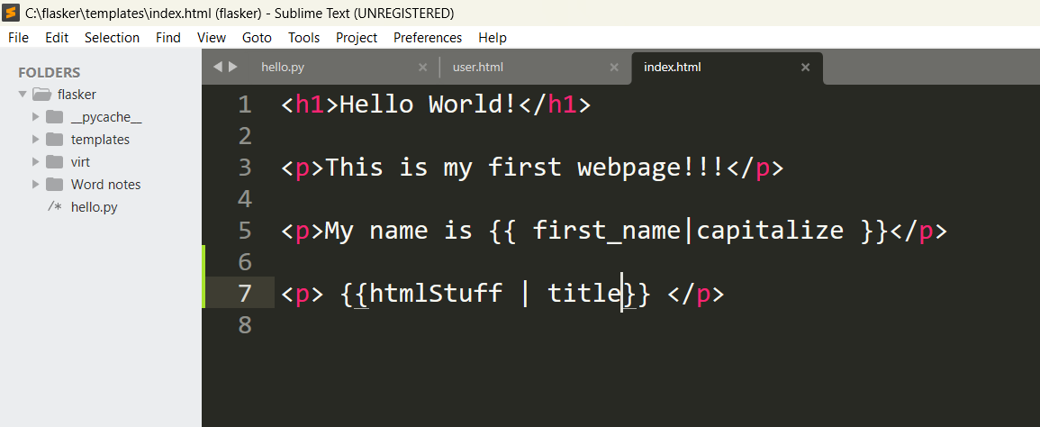

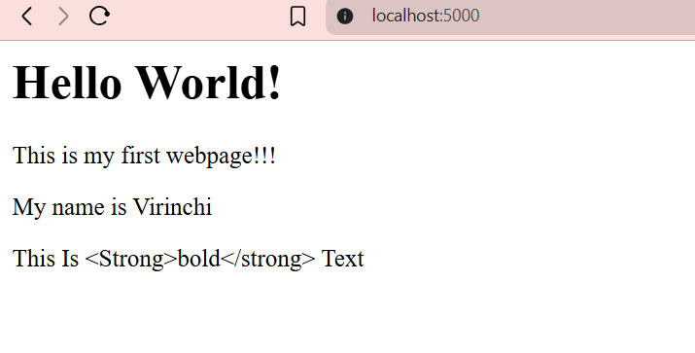

- 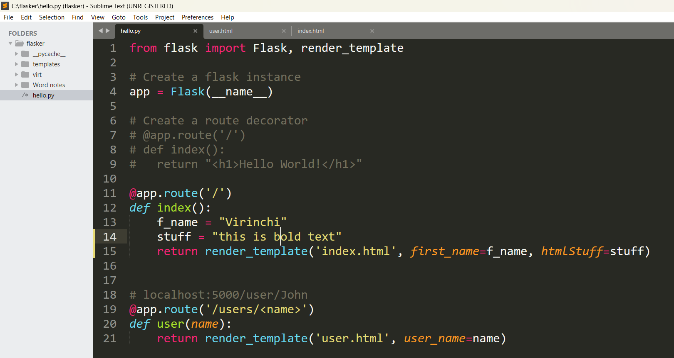
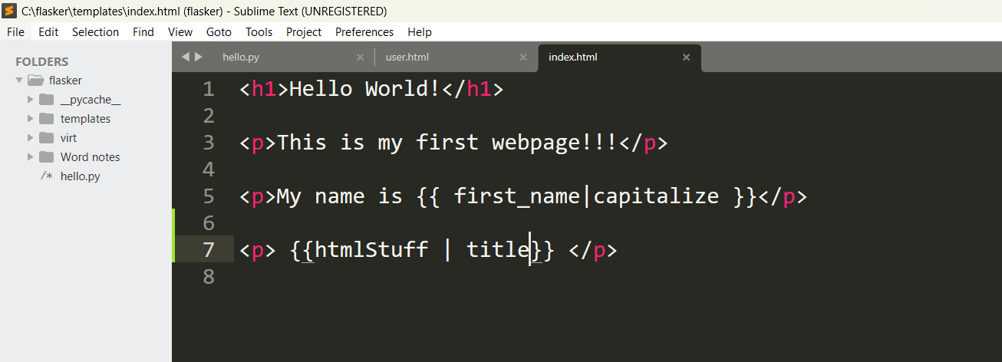

o/p: 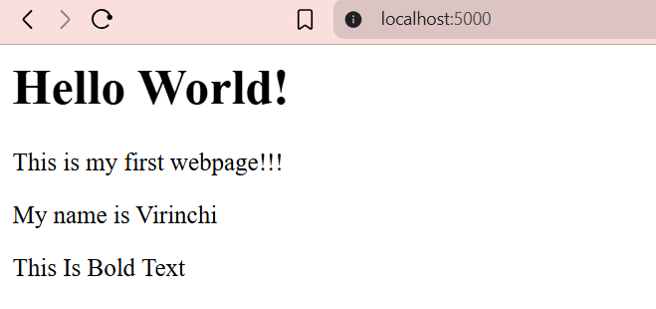

- 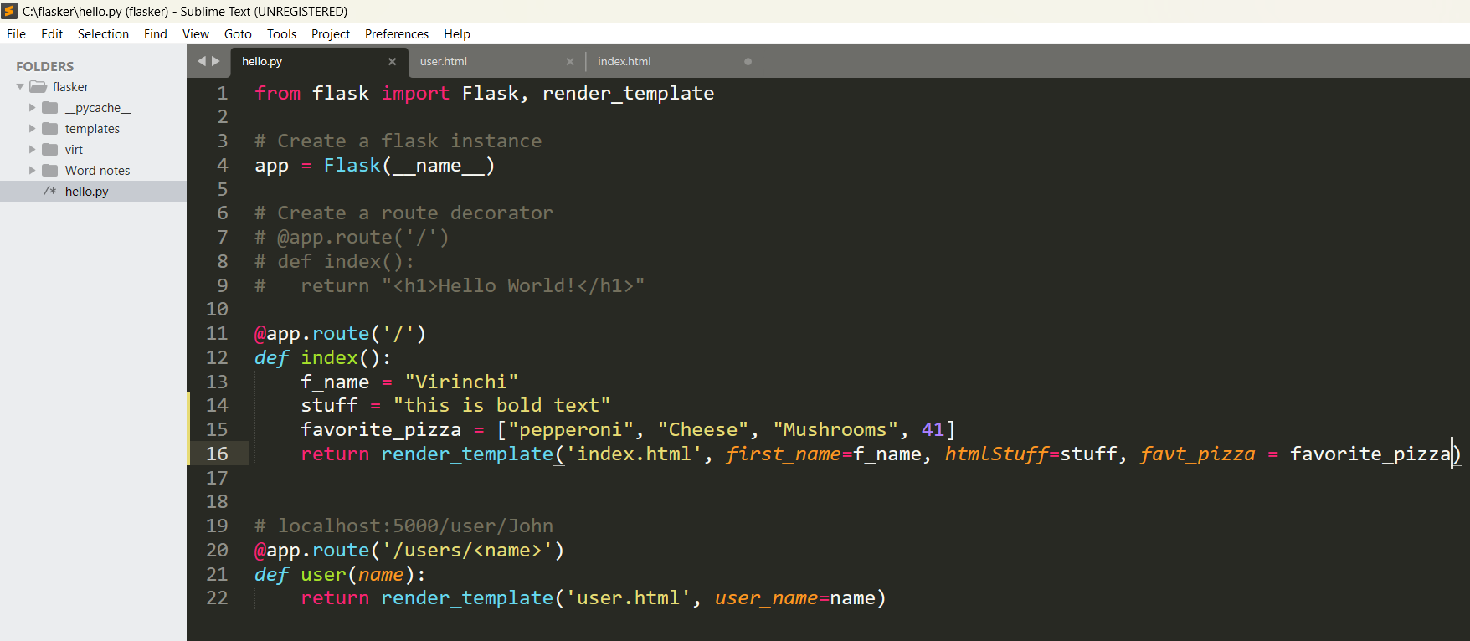

a)
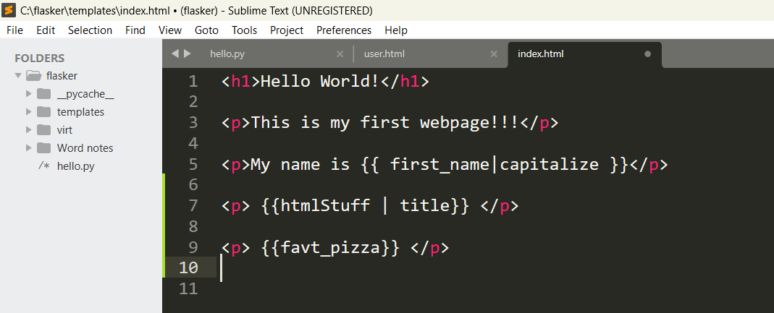

o/p:
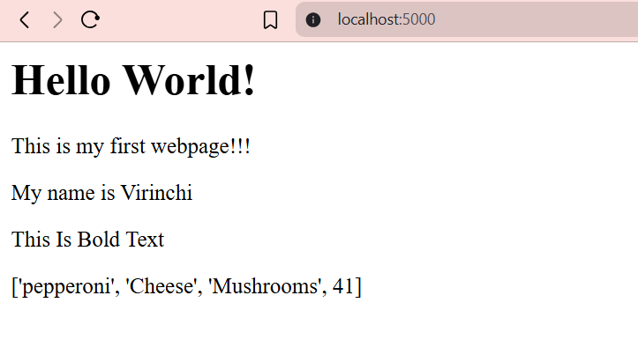
b) 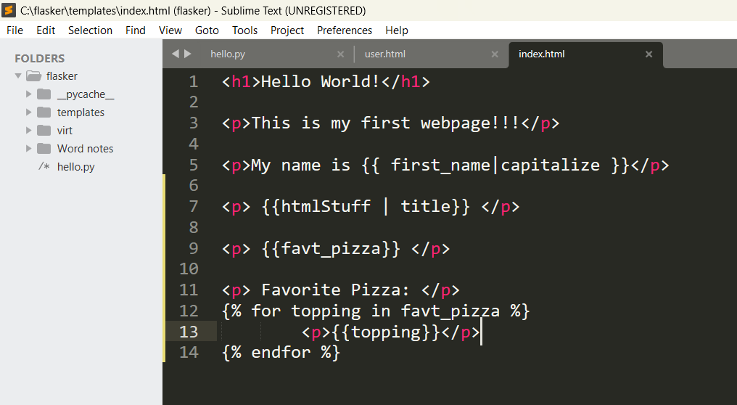

o/p:
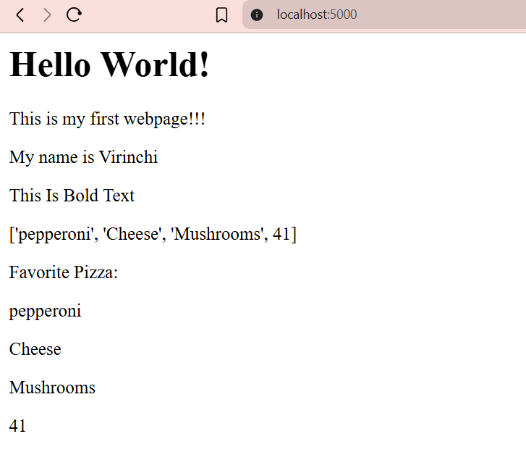
- 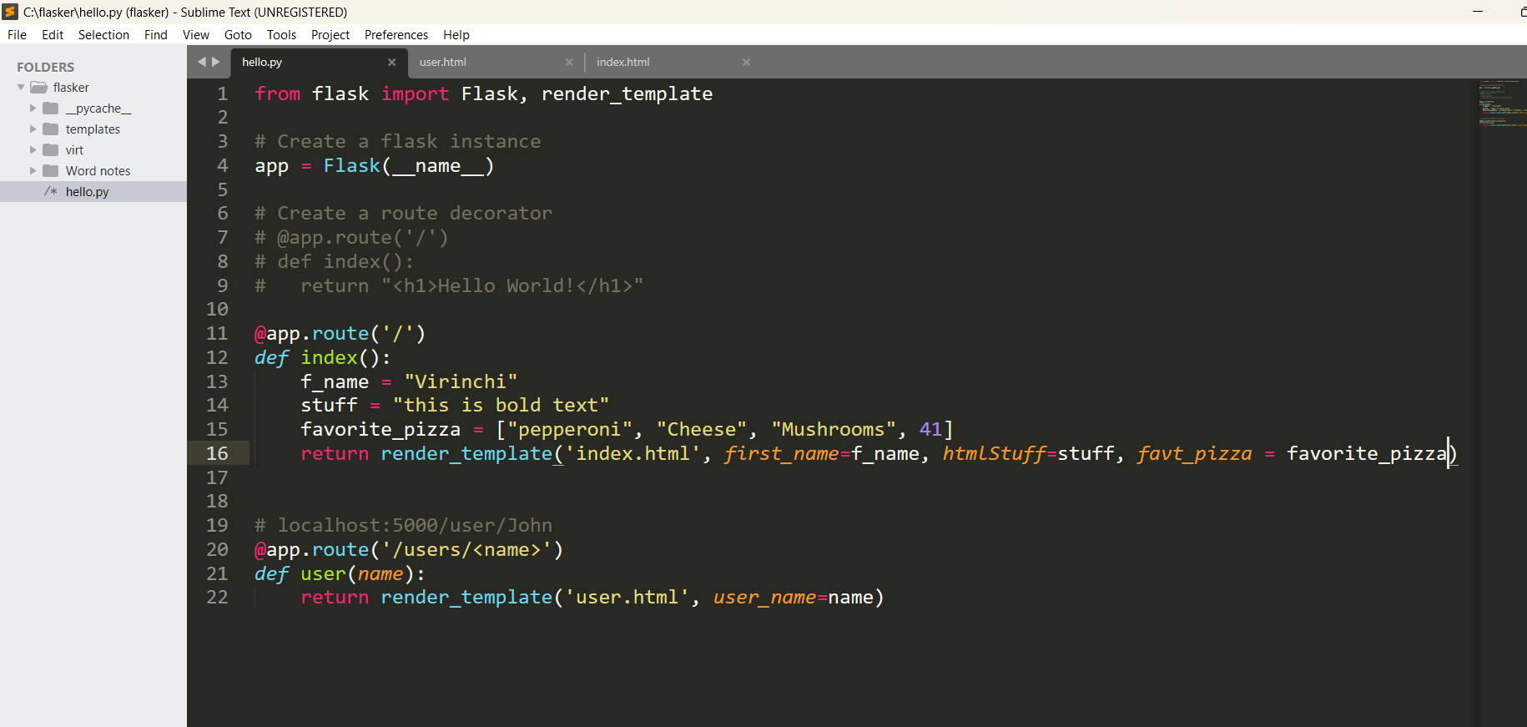

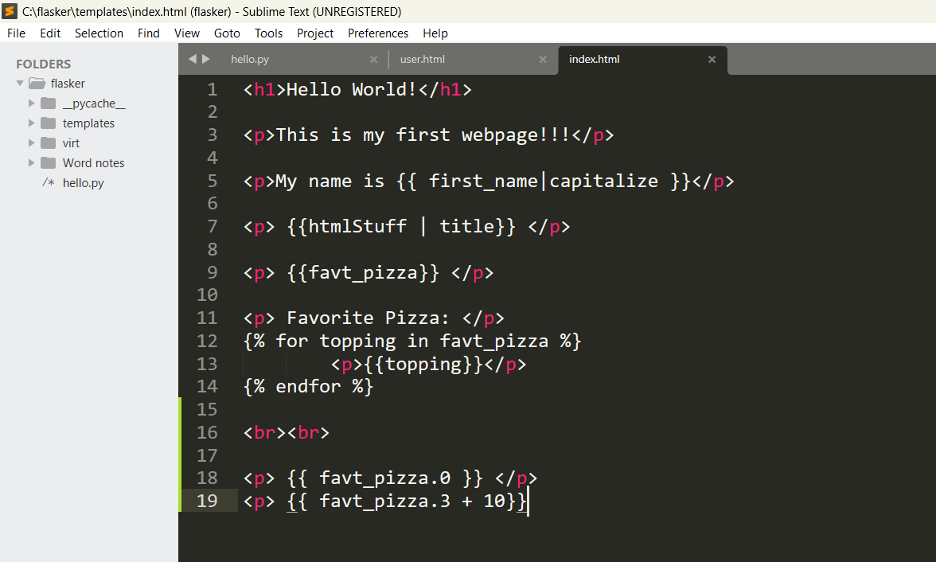

o/p:
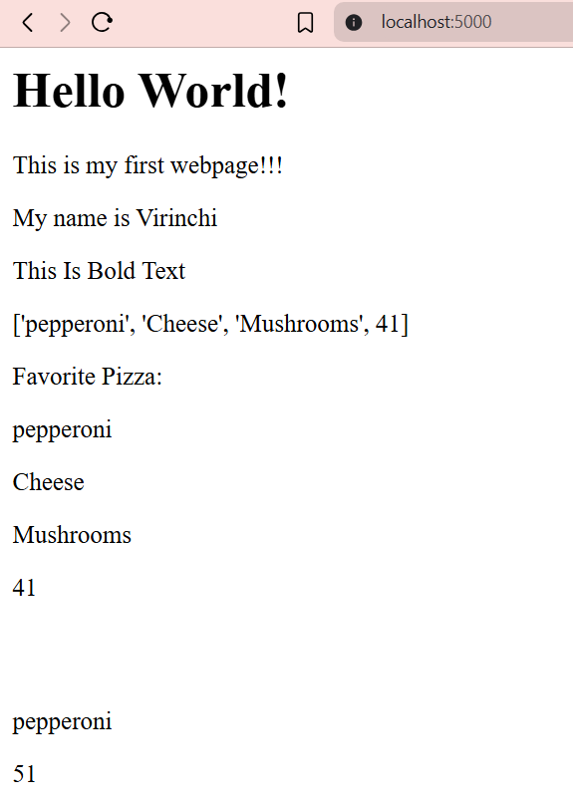

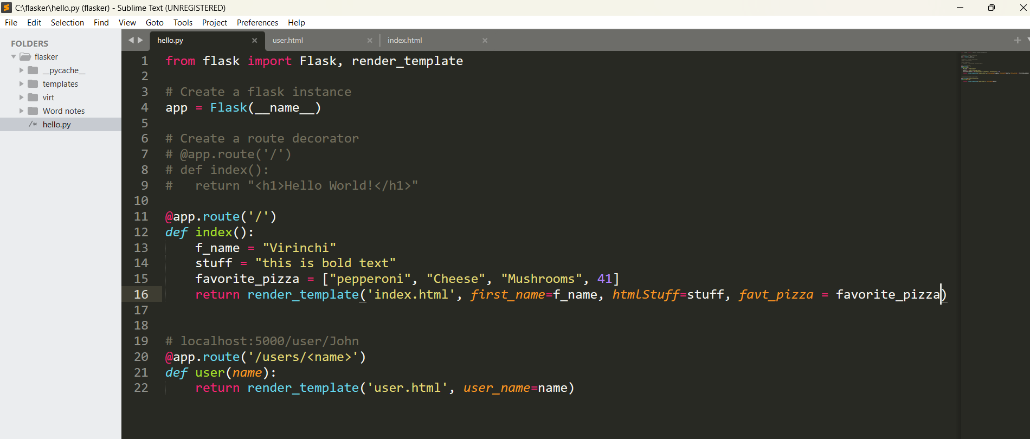

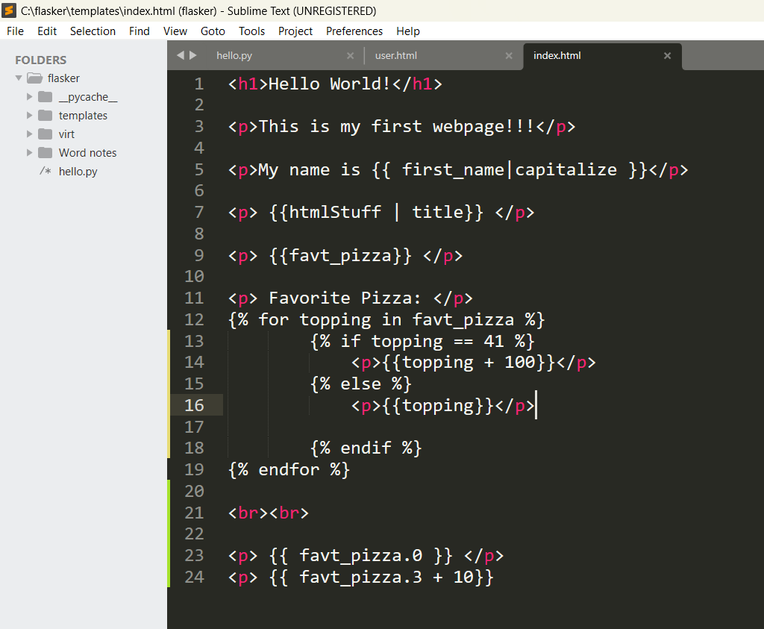

o/p:
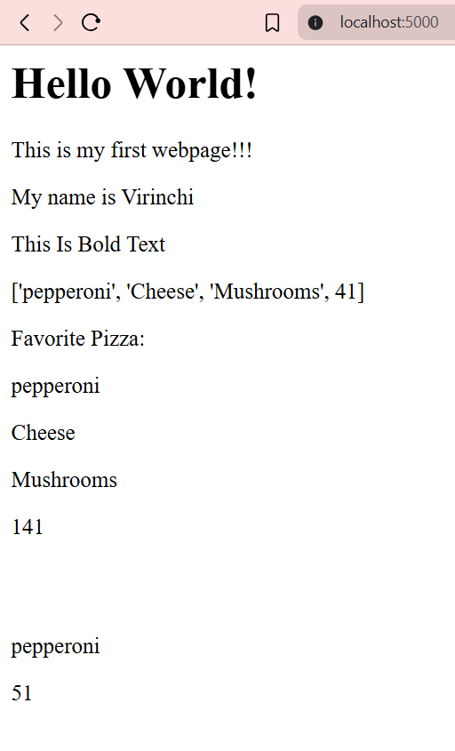

Documentation:
a) For filters: https://jinja.palletsprojects.com/en/stable/templates/#filters
b) For Built-in filters: https://jinja.palletsprojects.com/en/stable/templates/#builtin-filters

- 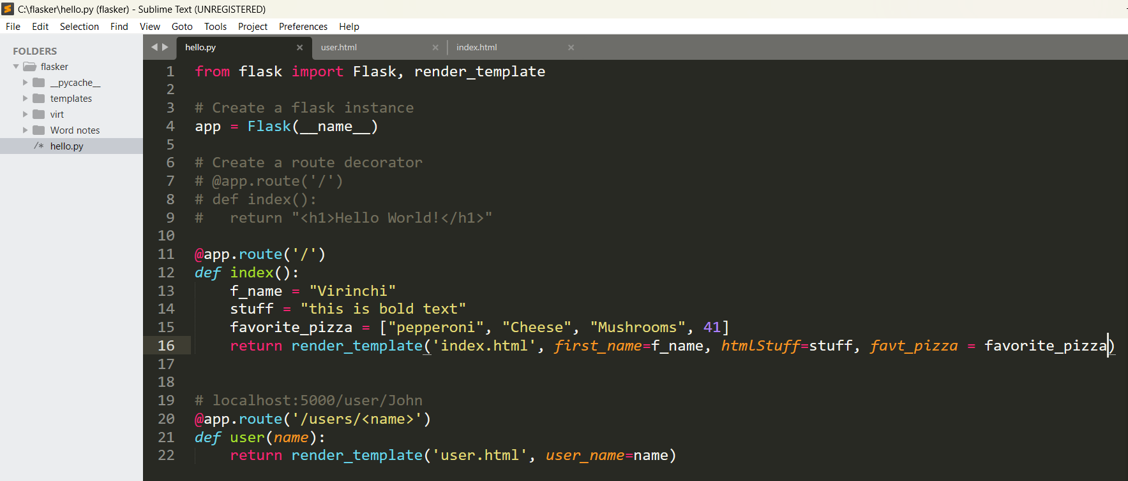
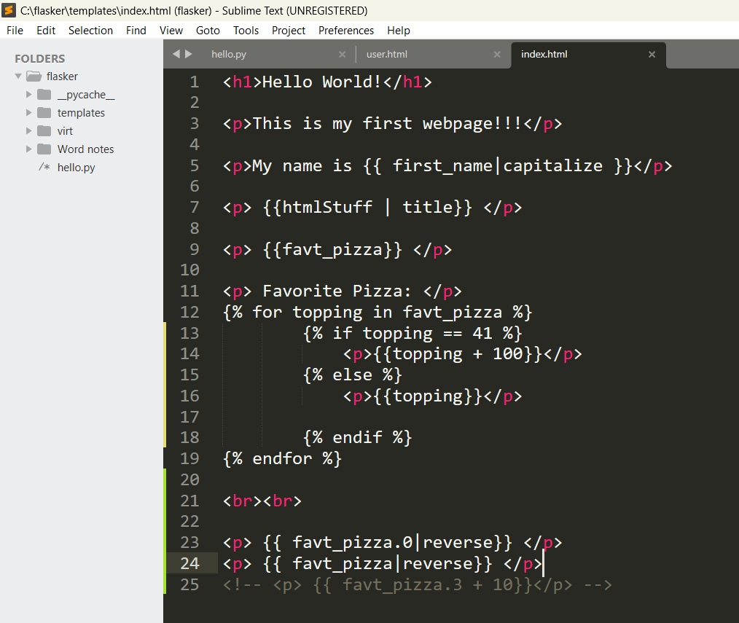

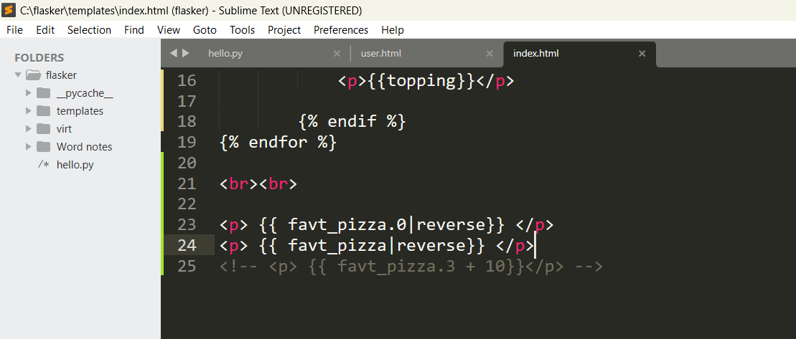

o/p:
